CUSTOM BOOTCAMP
Big Data and Azure Fundamentals

Difference between Star schema and Snowflake schema
- Star schema is a top-down model whereas snowflake schema is bottom-up model.
- Star schema uses more space than snowflake schema.
- Normalization is not present in star schema whereas both normalization and denormalization are used in snowflake schema.
- Star schema takes less time for execution of queries as compared to snowflake schema.
- Snowflake Schema has further division of snowflake schema which is not present in star schema.

Rapidly Changing Dimension
It is a dimension which has attributes where values will be getting changed over.

Slowly Changing Dimension
- It is a concept in data warehousing and database management that deals with managing changes to dimension data over time.
- Dimension data includes descriptive attributes like customer names, product categories, or geographic locations, which are often used for analysis, reporting and data visualization.
- Slowly Changing dimensions are categorized into different types (Type 1, Type 2, Type 3, and more) based on how historical changes to dimension data are handled.

Type 1 – Overwrite
- In this approach, the old data is simply overwritten with the new data when changes occur.
- Historical data is lost, and the dimension table reflects only the latest state of the data.
- Useful when historical data is not critical or when keeping track of changes is not necessary.

Type 2 – Add New Row

Type 3 – Add New Attribute

ETL (Extract Transform Load)
ELT (Extract Load Transform)

Enterprise Data Warehouse (EDW): It is a form of centralized corporate repository that stores and manages all the historical business data of an enterprise.
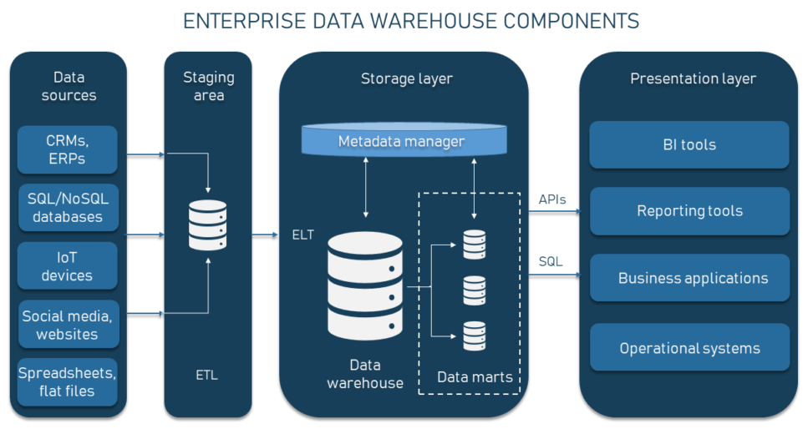
Staging Area
- Serves an intermediate space where data is aggregated, cleaned, and prepared before being loaded into the EDW.
- Ensures that data is in a consistent and useable format, ready for further processing and analysis.

Denormalization
- Denormalization in DBMS is a database design technique that involves intentionally introducing redundancy into a relational database schema to improve query performance.
- While normalization is the process of organizing data to minimize redundancy and data anomalies, denormalization is used when the priority is optimizing read performance for specific type of queries.

Overview on Big Data
- Big Data refers to the vast and complex volume of data that exceeds the processing capacity of traditional database systems and require specialized tools and techniques to store, process, and analyze effectively.
- It encompasses large datasets that are difficult to manage, process, and analyze using traditional data processing methods.

Four V’s of Big Data
- Volume
- Velocity
- Variety
- Veracity

Other V’s
- Value
- Visualization
- Virality

Characteristics of Big Data
- Volume: Big Data involves massive volumes of data that can range from TB to PB and beyond.
- Velocity: Data is generated and collected at high speeds, often in real time, from various sources like sensors, social media, and devices.
- Variety: Data comes in diverse formats such as structured (relational databases), semi-structured (XML, JSON) and unstructured (text, images, videos) data.
- Veracity: Refers to the quality and accuracy of the data, as Big Data sources may produce noise, inconsistent or unreliable data.
- Value: Extracting valuable insights from Big Data can lead to improved decisions making new revenue opportunities, and better customer experience.
- Variability: Data flows can be unpredictable and vary over time. Handling inconsistent data patterns is a challenge.

Challenges of Big Data
- Storage and Management: Storing and managing massive volumes of data requires distributed and scalable storage systems.
- Processing Power: Traditional processing tools may struggle to handle the processing demands of Big Data. Distributed computing and parallel processing are needed.
- Data Integration: Integrating and combining data from different sources with varying formats is complex.
- Data Quality: Ensuring data quality and accuracy when dealing with diverse and rapidly produced data is a challenge.
- Privacy and Security:

Big Data Architecture Style

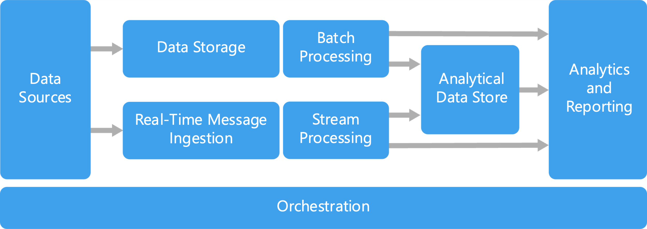

Azure Data Explorer Architecture

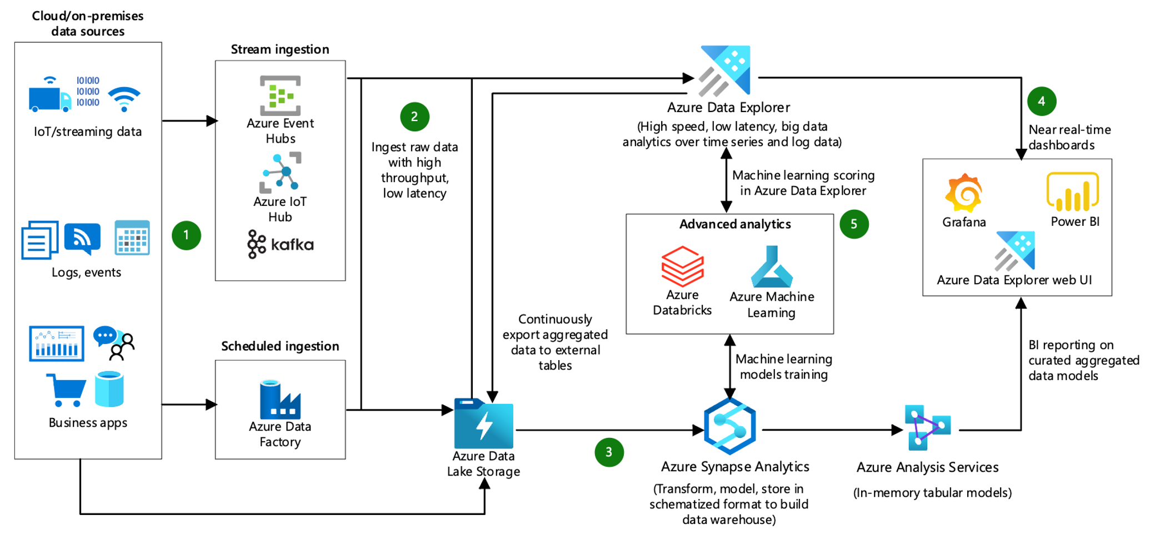

Cloud Service Models
- Infrastructure as a Service
- Platform as a Service
- Software as a Service

Importance in Big Data
- Structured Data: Traditional relational databases have been managing structured data for decades, The analysis is relatively straightforward, making it useful for reporting and decision-making.
- Unstructured Data: Unstructured data forms a significant portion of Big Data. Extracting insights from it requires advanced technologies like text mining, sentiment analysis, and image recognition.
- Sem-structured Data: Semi-structured data is often encountered in media and IoT devices. It’s used to capture data with …….

Structured Data
- Refers to the data that is highly organized, adheres to a fixed schema, and fits neatly in a table.

Unstructured Data
- Data that lacks a predefined structure or schema.
- Does not fit neatly into rows and columns and is typically more challenging to process.
- Data can include text, images, videos, audio recordings, and more, making it diverse and complex.
- Unstructured data comes from social media, emails, sensor readings, and other sources.
- Extracting meaningful insights from unstructured data often requires advanced techniques like NLP or ML.
- Example: social media posts, customer reviews. audio recordings, images.

Semi-structured Data
- Lies between structured and unstructured data.
- Possesses some structure such as tags, labels, or hierarchical relationships. But does not confirm to a strict schema,
- Allows for variability in its structure while still having some level of organization.
- May contain nested elements, making it suitable for representing complex relationships.
- Example: JSON, XML, log files.

Tools used to solve the problem of Big Data
- Various tools and technologies have been developed to address the challenges posed by Big Data.
- These tools enable the storage, processing, analysis.

Hadoop
- It is an open-source framework that enables distributed storage an processing of large datasets across clusters of commodity hardware.
- Core components include Hadoop Distributed File System (HDFS) for storage and MapReduce for data processing.
- Used for batch processing, data storage and scalable data processing.

HDFS Architecture
- HDFS has a master-slave architecture.
- HDFS cluster consist of a single NameNode, a master server that manages the file system namespace and requires regulate accesses to files by clients. In addition, there are several DataNodes, usually one per node in the cluster.
- NameNode: A commodity hardware that contains …….
- HDFS is designed to reliably store very large files across machines in a large cluster. It stores each file as a sequence of steps. The blocks of a file are replicated for fault tolerance.

Apache Spark
- An open source, fast and general-purpose cluster computing system for Big Data analytics.
- Provides support for in-memory data processing, real-time streaming, machine learning, and graph processing.
- Offers high performance that Hadoop’s MapReduce due to in-memory processing capabilities.

NoSQL Databases
- NoSQL databases like MongoDB, Cassandra and HBase are designed to handle large volumes of unstructured or semi-structured dat.
- Suitable for real-time applications, web services, and scenarios where high availability and scalability are crucial.

Types of NoSQL Databases
- Column
- Graph
- In-memory
- Key-value
- Document

Apache Kafka
- It is a distributed streaming platform used for building real-time data pipelines and streaming applications.
- Efficiently handles high volumes of streaming data and enables real-time analytics.

Elasticsearch: A distributed search and analytics engine that can handle and search large volumes of data quickly.

Kibana: A data visualization tool that work s seamlessly with Elasticsearch, allowing users to create dashboards and visualizations.

Data Lake
- A data lake is a centralized repository that allows you to store, manage, and analyze vast amounts of structure, semi-structured and unstructured data.
- Unlike traditional data warehouses, which follow a structured schema, data lakes provide a more flexible and scalable approach to storing and processing data.
- Data lakes are designed to accommodate Big Data and support various analytics and machine learning tasks.

Data Lake Architecture
- The lower-level architecture represent data that is mostly at rest while the upper levels show real-time transactional data.
- The data flows through the system with no or little latency.

We can build the data lake solutions through the following services:
- Azure HD Insight It is a managed full spectrum, open-source analytics service in the cloud for enterprises.
- Azure Data Lake Store: It is a hyperscale Hadoop-compatible repository.
- Azure Data Lake analytics: It is an on-demand analytics job service to simplify big data analytics.

Ingestion Tier: The tiers on the left side depict the upper source. The data could be loaded into

HDFS is a cost-effective solution n for both structured and unstructured data. It is a landing zone for all data that is at rest in the system.

Distillation Tier: Distillation tier lakes data from the storage tire and converts t to structured data for easier analysis.
Processing tier run analytical algorithms and user queries with varying real-time, interactive, batch to ……

Creating a Virtual Machine